Leap year

Is leap Year

1. Read year.
2. Is year divisible by 400. year : p
3. Is year divisible by 4. year : r
4. Is year not divisible by 100. year : q
5. If p : is Leap Year  
   else if r and q : is Leap Year  
   else : Is not Leap Year

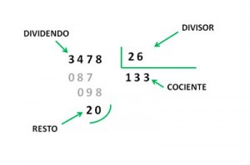

Dividend = divider \* quotient + rest

Is year divisible by a number : true/false

1. Read year
2. quotient = Year/number
3. if quotient \* number == Year : true  
   else false